Using Excel

Objectives:

Create Code Modules and GUI within Excel

Where to Look for Help:

www.Millburn.org/Farrell

Go to the CS 1 Link and goto the “Class Lecture and Documents” link

Teacher Notes, Program Example Code & other Items are in the
“Using Excel” Topic

All Example Code or Projects are in ZIP format and need to be downloaded and UNZIPPED

VB.NET’s Online Help. Highlight any VB Object and hit F1 for Help

LAB: Work with Math Matrices ---- Hand Written Lab Handout

Using Excel

Open Up Excel

Go to Tools…Macros…VB…Editor
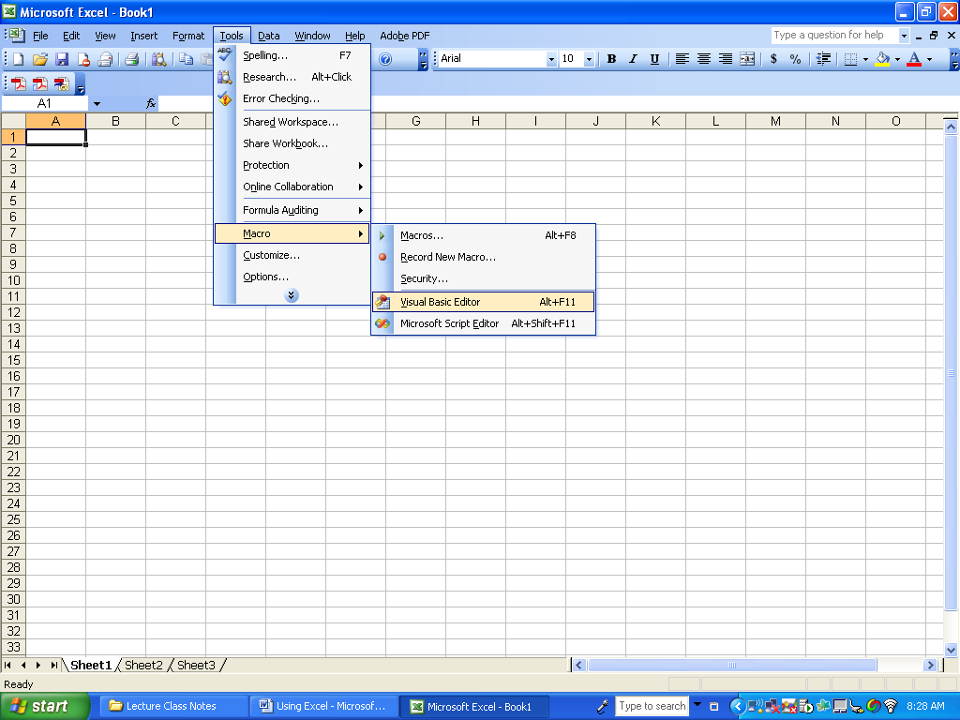

Once in the Editor you have the ability to manipulate ANY spreadsheet, Create new Spreadsheets and Perform calculations between spreadsheets by implementing VB code within methods of Excel.

As with VB.NET, you can create your own modules and methods as well as add in GUI objects like buttons and textboxes.

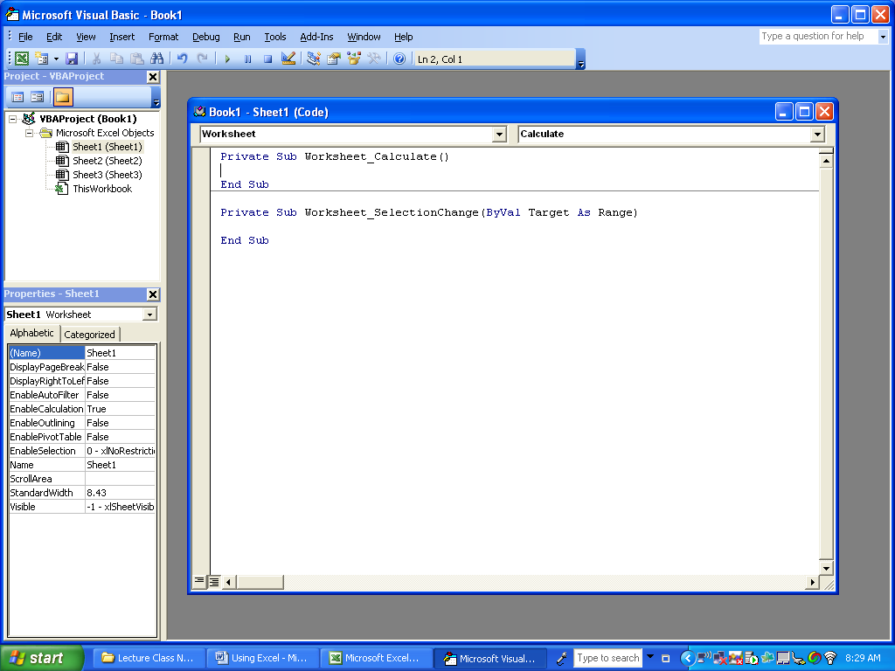

To Add a GUI Object, Select View…Toolbars… Select “Control Toolbox”

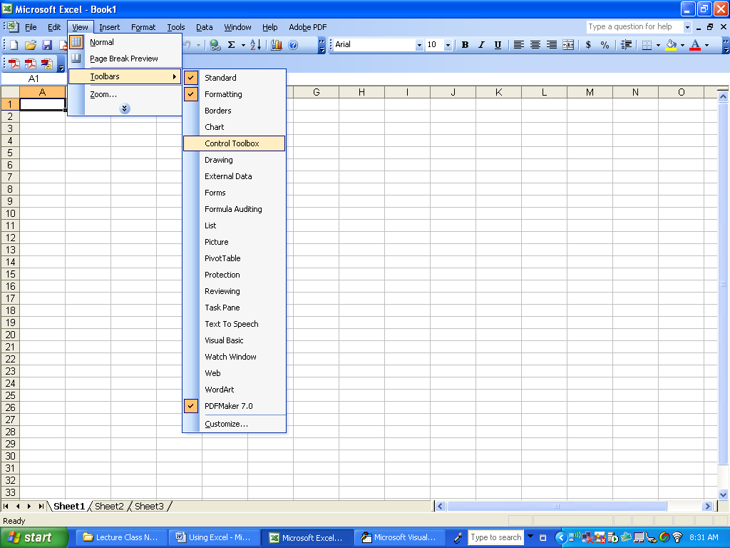

You can then add in a button by double clicking on the Button tool

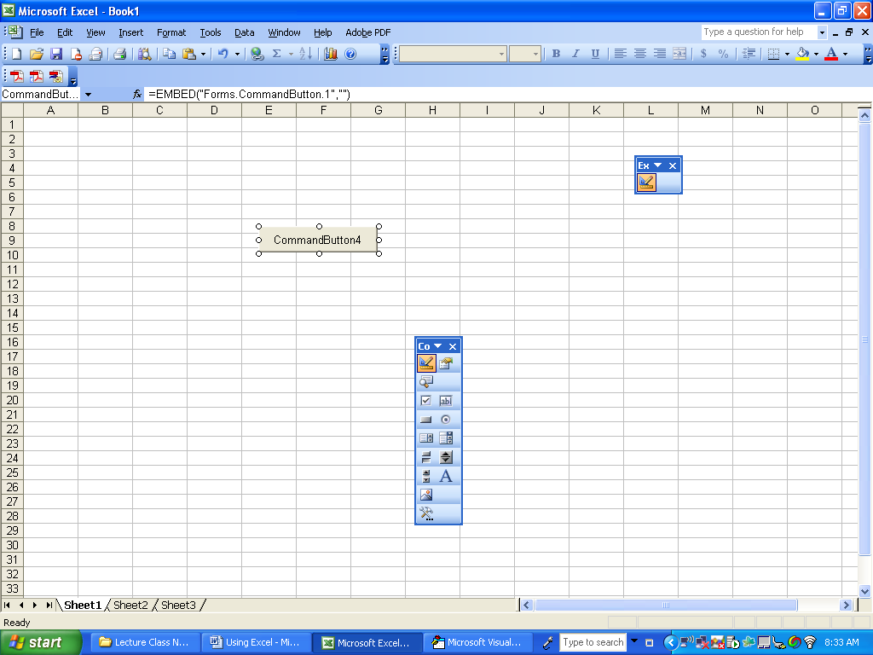

Double Click on the button to provide code for the button’s methods
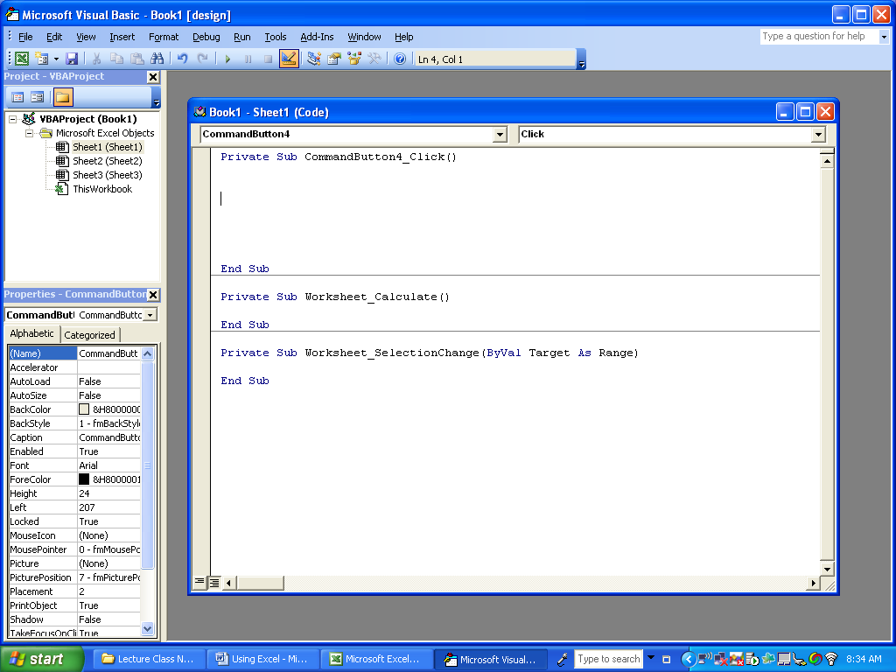

To exit out of the VB Editor, select File… Close and return to Excel

TO Toggle between Execution and Design Mode, click on the Design Mode icon:
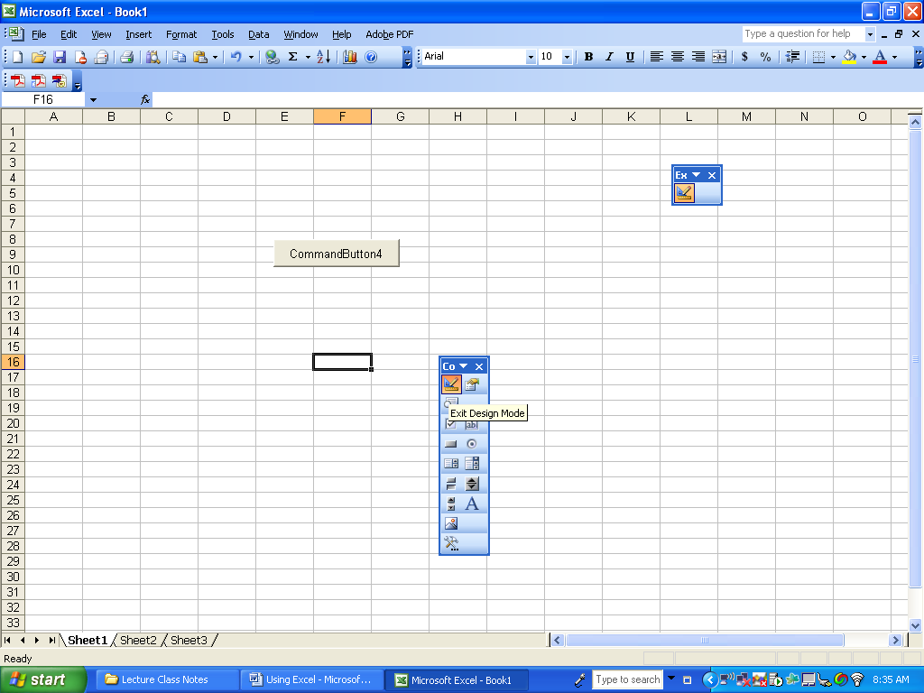

Code for Spreadsheet Example:

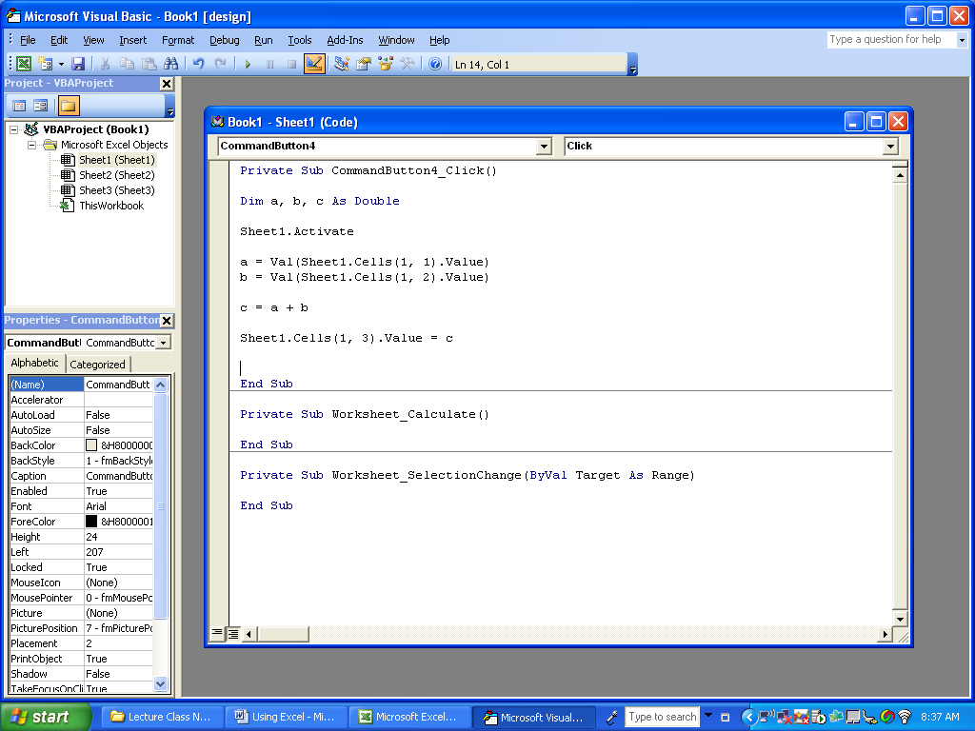

Activate the sheet and then access its cells

Close the editor and turn off design mode then click the button to test the code:
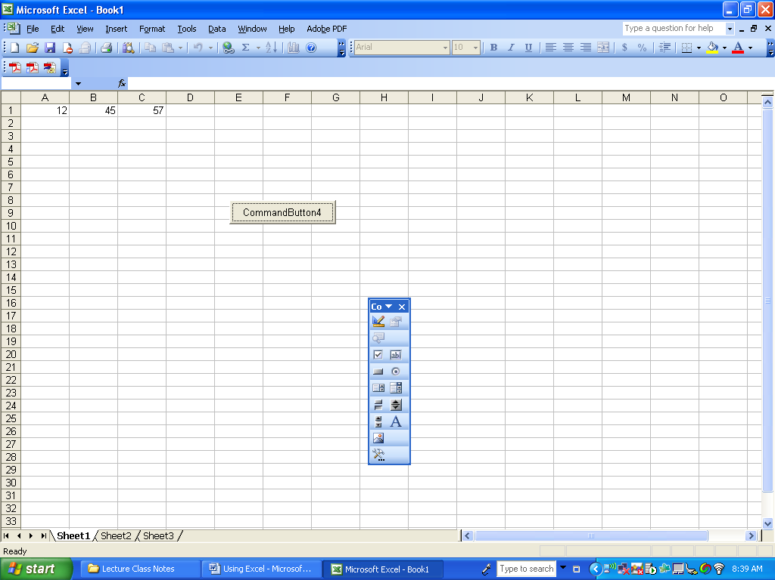

Use the MACRO tool to learn how to code for EXCEL opetations. Record the macro, perform the Excel operation to code for, then edit the MACRO to view the code.

